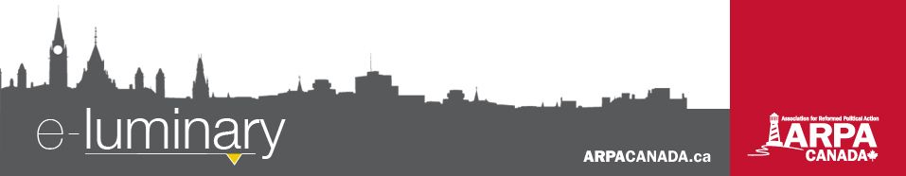
Association for Reformed Political Action (ARPA) Canada: January 2018
God & Government 2018
God & Government is our signature three-day event in Ottawa that provides Reformed Christians with the opportunity to meet with Parliamentarians and to train and strategize with other Christians.
Thanks to very generous donors, this event is heavily subsidized. We ask that all those interested in attending apply at ARPACanada.ca/GG18. Filling out the form does not guarantee your spot at the conference, but we will endeavour to advise the successful applicants as soon as possible. Early bird registration ends February 5.
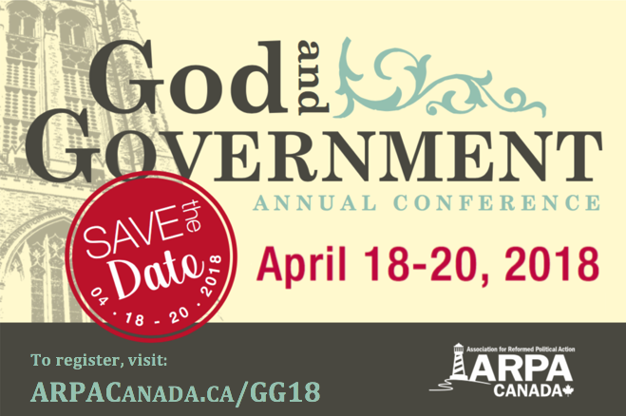
We have special rates for pastors and teachers of Reformed churches and schools, as well as Boots on the Ground members (full pricing details can be found on our website).
The final application deadline is March 17. Payment in full is due at that time.
We will provide three nights’ accommodations at the Sheraton Hotel, most meals, training and talking points to assist with meeting government officials, and assistance by phone or email with preparations.
If you have any questions, please contact our Event Coordinator, Hannah Sikkema, at 1-866-691-2772, ext. 1 or via email: Hannah@ARPACanada.ca.
Letter to the Editor Contest Winners Announced!
Western Canada came out on top in our 2017 Letter to the Editor contest! We received 47 submissions in total which were read by tens of thousands of Canadians. To all of you brave writers, we heartily thank you for courageously sharing your convictions with your communities and this nation.
We also sincerely wish to thank Compass Creative for providing five generous prizes of $200 gift certificates to Amazon.ca, one for each of the following categories:
- Most Letters Published: Stanley Reitsma, Carman MB
- Best Letter in Large Newspaper: Jonathan Van Schepen, Devon AB
- Best Letter in a Community Paper: Jennifer Otten, Barrhead AB
- Best Letter by Someone Under Age 20: Jodi Devries (age 13), Smithers BC
- Random Winner of all the Entries: Jane Oosterhoff, Dunnville ON

We were encouraged by the caliber of the letters submitted and the impact they have had. Slowly but surely we are seeing more Christians exercise their prophetic calling by using this free and effective medium. If you ever would like someone from the ARPA staff to edit or give feedback on a letter, be sure to email it with a deadline to info@arpacanada.ca.

Canada Summer Jobs Program
Every year the government spends millions of taxpayer dollars on the Canada Summer Jobs program. This program allows employers to apply for wage subsidies to hire students and is open to both not-for-profits and businesses. The objective is to give students meaningful summer work experience and to support organizations that provide community services. This year, for the first time, applicants must agree to the following attestation on the form:

Everything we do is to be done to the honour and glory of God. We encourage you to join us in prayer as we carry out our mission.
PRAISE:
- For the impact the Letter to the Editor contest had on readers across Canada!
- For the positive relationships being built with elected representatives through the 12 step action plan.
PRAYER:
- For our Members of Parliament and provincial representatives who will return to their offices at the end of this month.
- That our supporters across the country would be educated, equipped, and encouraged for political action throughout 2018!
Praise &
Prayer
Both the job and the organization’s core mandate respect individual human rights in Canada, including the values underlying the Canadian Charter of Rights and Freedoms as well as other rights. These include reproductive rights and the right to be free from discrimination on the basis of sex, religion, race, national or ethnic origin, colour, mental or physical disability, sexual orientation or gender identity or expression.
Clearly the government has created an ideological test for employers who hope to take part in this initiative. They are seeking to prevent organizations that hold pro-life views - even if they do not do pro-life advocacy - from receiving funding.
The government should remove the attestation requirement.
You can help.
Visit Easy.ARPACanada.ca to send an EasyMail to your MP. Let them know the problems you have with this policy and what you think about an ideological screening test. Let them know if you have used this program (either as an employer or a student) and the impact the loss of funding will have on your community. Visit ARPACanada.ca/summerjobs for more analysis on this issue.
12 Step Action Plan Continues
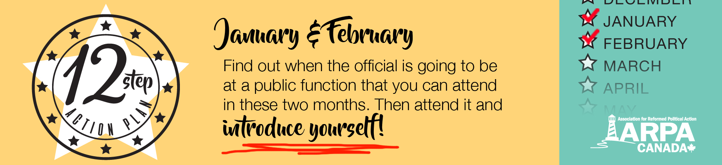
Our 12 Step Action Plan continues in 2018 with the January and February action items: find out when your official is going to be at a public function you can attend, and introduce yourself. Express your interest in meeting for coffee in the coming weeks. The action plan gives you two months to both find an event and attend it. For this one, when you complete it you can check off January and February! If you haven’t heard of this plan, visit ARPACanada.ca/12steps for more information and to watch an introductory video explaining how it works. If you haven’t started yet, don’t worry, you can easily catch up. Or start this month taking it one month at a time with completion in December 2018!

“Rejoice in hope, be patient in tribulation, be constant in prayer.” ~ Romans 12:12
Contact Us: 1-866-691-2772 | info@arpacanada.ca
Donations can be directed to: ARPA Canada PO Box 1377 STN B, Ottawa Ontario K1P 5R4

