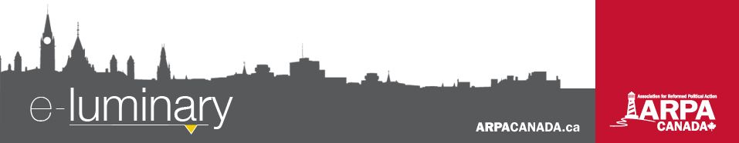
Association for Reformed Political Action (ARPA) Canada: December – 2016
Quick Updates:
- ARPA and We Need a Law are pairing up for a nine-city tour of Ontario in January to reveal how the government is hiding abortion statistics, and thus frustrates the ongoing work of advancing pre-born human rights and helping Canadian women. For more details, visit WeNeedaLaw.ca/stop-censorship-tour.
- Bill C-16 (transgenderism) has now been sent to the Senate. If passed, this bill will amend the Canadian Human Rights Act to outlaw discrimination on the basis of “gender identity” and “gender expression”. You can read more of ARPA’s analysis on this issue at ARPACanada.ca/news/bill-c-16.
- Bill 28 (“All Families Are Equal Act”) passed unanimously in the Ontario legislature on November 28, with a vote of 79-0. Please remember our elected officials and the ongoing attack on the family. A post-mortem of this bill is available at ARPACanada.ca/news/bill-28-postmortem.
- Bill C-277 (palliative care) was scheduled to go for second hour of second reading on December 13. At the time of this writing, we do not yet have the results of the vote. Please continue to interact with your MP and ask them to support this important bill. More information is available at ARPACanada.ca/palliative-care.
Motion 47 Passes Unanimously

Motion 47, introduced by MP Arnold Viersen this past spring, asks the Health Committee to examine the public health effects of the ease of access and viewing of online violent and degrading sexually explicit material on children, women, and men and report its findings to the House no later than July 2017. The motion went for a final vote in the House of Commons on Thursday, December 8, and passed unanimously. This study will mark the first time in 30 years that Parliament has studied the issue of pornography in Canada.
A huge thank you to all who responded to our calls to action by sending EasyMails, signing petitions, calling MPs, engaging on social media, and spreading the word about this very important motion! We are so grateful that your voices were heard and that our parliamentary leaders have turned their minds to the evils of pornography.
God and Government Youth 2017
Calling all Reformed youth! We are very excited to announce that we will be hosting our first ever God and Government Youth conference this coming May at our new Ottawa office. Applications are open to any grade 11 or 12 students attending a Reformed church in Canada.
Ready, set, ACTION!
Send a Christmas EasyMail or handwritten card to your MPP/MLA or MP, thanking them for their service. Use this as an opportunity to share the hope of Christ’s birth with those in public office!
EasyMails are available at Easy.ARPACanada.ca.
We would also encourage you to attend events in your MPs riding to get involved and show your support!
Please note that this conference is free of charge* and some highlights include:
- Tours of Parliament/Supreme Court
- Fun night (“Escape Manor”)
- Formal Banquet
- Speakers and workshops
- The annual March for Life
The deadline for applications is January 31, 2017.
We anticipate a high level of interest so apply today!
Please contact ARPA’s administrative assistant, Hannah Sikkema, at Hannah@ARPACanada.ca if you have any questions.
*Travel costs are not covered by ARPA
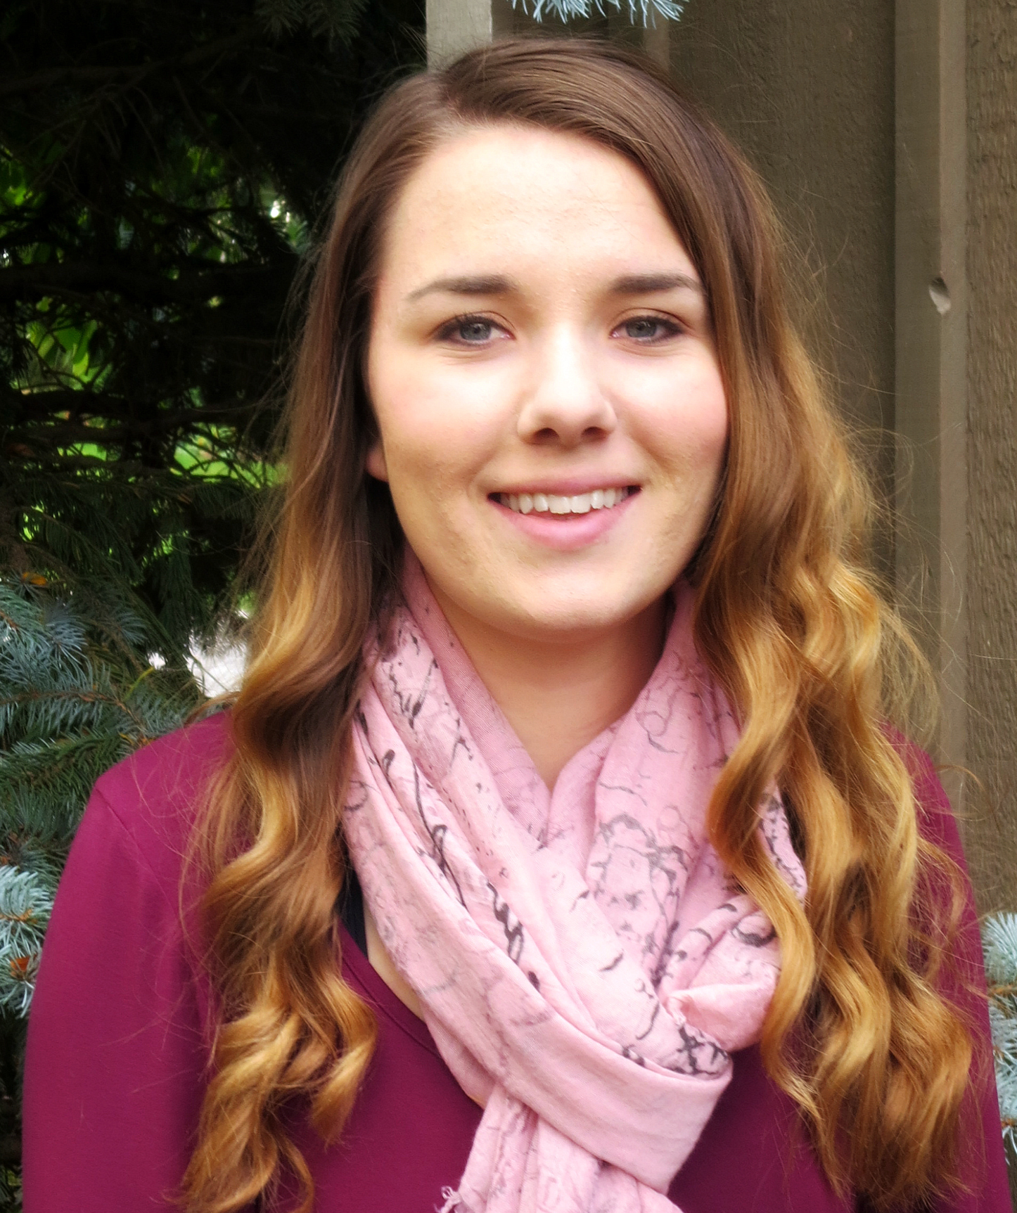
Welcome to our New Office Manager
In November we welcomed Hannah Sikkema to the Ottawa office as our new full-time Office Manager/Administrative Assistant. She has taken over the majority of Niki Pennings’ responsibilities, as Niki and her husband look forward to welcoming children into their home as foster-to-adopt parents.
Hannah is primarily responsible for managing the Ottawa office, supporting the Law and Policy team by coordinating meetings with various government officials, booking travel, and keeping contact lists and communications (social media and newsletters) up to date. She will also coordinate the logistics of ARPA’s events (including the God & Government conference, the Fall Tour and various provincial conferences).
Bill S-206 on Amending the Criminal Code
Bill S-206, “An Act to amend the Criminal Code (protection of children against standard child-rearing violence)”, will, if passed, remove a provision of the Criminal Code (section 43) that permits parents to use limited, minor physical force on children for disciplinary purposes.

Everything we do is to be done to the honour and glory of God. We encourage you to join us in prayer as we carry out our mission.
PRAISE:
- For a unanimous vote in support of Motion 47. Thank you to all those who took action to make this possible!
- For the hard work and passion of Niki Pennings in her role as ARPA’s Administrative Assistant and for the addition of Hannah Sikkema who was able to take on this role full-time.
- For God’s grace in guiding us through another year and for your continued support of ARPA’s work and mission!
PRAYER:
- For the attack on God’s design for the family with the passing of Bill 28.
- For Christian schools across Canada that are being labeled “discriminatory” for upholding faith-based codes of conduct and hiring policies.
- For travelling mercies for staff and their families over the Christmas holidays.
Praise &
Prayer

It would mean that even disciplinary force that is sober and reasoned, addresses actual behaviour, and is intended to restrain, control, or express symbolic disapproval of a child’s behaviour, would amount to assault.

You may be thinking, “Haven’t we heard about this issue from ARPA before?” Well, you probably have. ARPA wrote a Policy Report on Corporal Discipline in 2013, and recently updated that report. It is available at ARPACanada.ca/publications.

Please take the time to send your MP a letter expressing your concerns about Bill S-206. We have two draft EasyMails (available at Easy.ARPACanada.ca) to get you started. As always, edit them as you like, and please be respectful. Thank you!
Final Lighthouse News of 2016
Tune in to LighthouseNews.ca on Tuesday, December 20, for our final episode of 2016. Our host, Al Siebring, will provide a year in review, highlighting all of the big news stories of 2016.
You don’t want to miss it!
Another Year is Dawning…
Dear Father, let it be! As we come to the close of another year and look forward to celebrating the birth of our Saviour, we take time to reflect on the past year and see how God has been our faithful guide through all of the ups and downs of 2016. As Paul proclaims in Romans 8:28, “And we know that for those who love God all things work together for good, for those who are called according to his purpose.”
As Christians, we know that whatever trials or triumphs we face on our earthly walk, God is in control and His plans are sovereign. It is our prayer that you would experience the true joy of Christmas through the everlasting love of our heavenly Father who sent His only Son for us.

Wishing you and your family a joyous Christmas and blessings in the coming year!
For to us a child is born, to us a son is given; and the government shall be upon his shoulder, and his name shall be called Wonderful Counselor, Mighty God, Everlasting Father, Prince of Peace. ~ Isaiah 9:6 ~
Contact Us: 1-866-691-2772 | info@arpacanada.ca
Donations can be directed to: ARPA Canada PO Box 1377 STN B, Ottawa Ontario K1P 5R4

