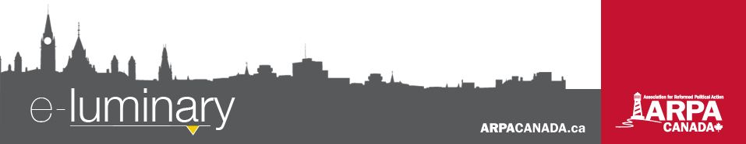
Association for Reformed Political Action (ARPA) Canada: February 2017
Quick Updates:
- Bill C-277 (palliative care) passed second reading in the House of Commons on January 31 with a unanimous oral vote in support and is now headed to the Health Committee for review. This represents a crucial step towards ensuring consistent access to palliative care across the country.
- M-103 – The “anti-Islamophobia” motion had its first round of debate in Parliament on February 15 and will return for a vote in April. For more information, visit ARPACanada.ca/m-103.
- The Health Committee began its first round of discussion earlier this month on Arnold Viersen’s Motion 47, which calls for a study on the mental health effects of violent online sexually explicit materials – particularly on young people. A date has yet to be set for when the study will take place so stay tuned for an update!
- Are you wondering what the big deal is about Bill C-16 (the "transgenderism bill")? Or do you need help explaining your concerns? Visit ARPACanada.ca/faqs-bill-c-16 for answers.
- ARPA is hiring! We are seeking a part-time Administrative Assistant to the We Need a Law Director, based in the Fraser Valley and a full-time Alberta Director. For more information on either of these positions, please visit the featured articles section on our website.
Ready, set, ACTION!
The Ontario Legislature is back in session. Now is the time to be heard on Ontario's Bill 89! Please visit Easy.ARPACanada.ca to send your MPP a message or take the time to phone their office (even better!). For more information, visit ARPACanada.ca/bill-89.

FIPPA Hearing Update
ARPA completed its legal arguments before the Ontario Superior Court in Ottawa on February 1. ARPA is challenging a provision of Ontario’s Freedom of Information and Protection of Privacy Act that allows the government to withhold all statistics related to abortions performed in the province. The outcome of this case is not certain – it could go either way. Your continued prayers for a favourable decision are coveted. For more information on this case, please visit ARPACanada.ca/fippa-update.
BC and Alberta Grassroots Tour
Want to learn how you can get involved practically to make a positive impact on your community? Colin Postma, ARPA’s Grassroots Manager, will be holding cultural engagement workshops focusing on generating new ideas for action, brainstorming new ways of engagement, and getting more people involved in Canadian cultural and political debate. If you think you know everything there is to know about ARPA, or if you know nothing about us but want to get involved with shaping culture, with the pro-life cause, or with Canadian politics, join us for one of these workshops in your area. Please see event locations and details below (all events are from 7:30 – 9:30 p.m.):
Attention Administrators!
Will your class be visiting Ottawa this spring for a class trip? If so, we would love for you to stop by our new office for a tour and a small presentation on what ARPA is all about!
If you are interested, please contact Hannah at Hannah@ARPACanada.ca.

Langley Canadian Reformed Church
Monday, February 27, 2017

Chilliwack Free Reformed Church
Tuesday, February 28, 2017

Coaldale Canadian Reformed Church
Wednesday, March 1, 2017

Immanuel Canadian Reformed Church
Thursday, March 2, 2017

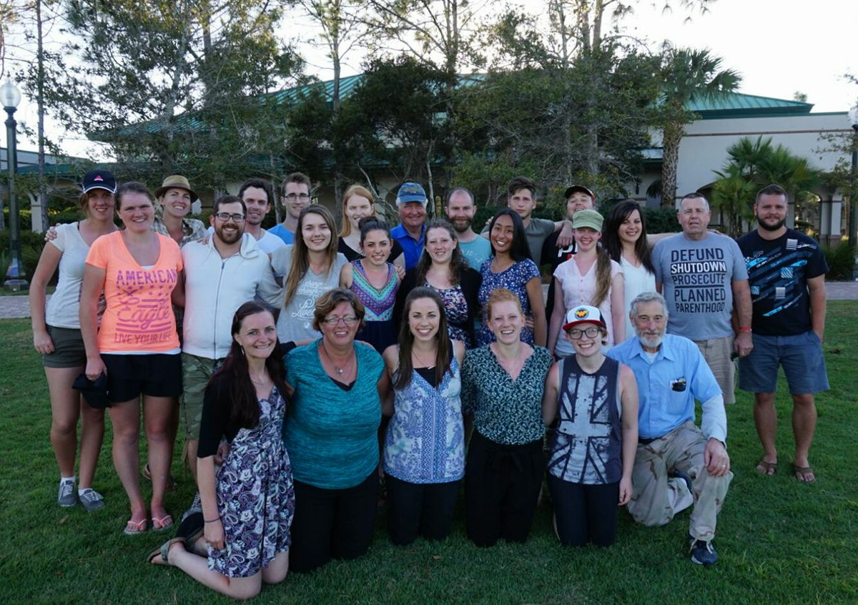
Pro-life Apologetics Training
"Reaching out in compassion, armed with the truth, consistently produces extraordinary results." - Jonathon Van Maren, Communications Director for the Canadian Centre for Bioethical Reform (CCBR)
Three of our staff members were in Florida for a week this month for pro-life apologetics training and activism (the “Human Rights Project”), hosted by CCBR. We learned how to interact with people on the issue of abortion by finding common ground, using analogies and asking questions. Along with a team of around 20, we went to various university campuses in Florida to do just that. The displays CCBR used at these campuses featured abortion victim photography to expose the truth of what abortion really does to children in the womb.

Everything we do is to be done to the honour and glory of God. We encourage you to join us in prayer as we carry out our mission.
PRAISE:
- For all of those (44 in total!) who applied to our God and Government Youth Conference.
- For the safety of our staff while travelling in Florida for pro-life apologetics training.
PRAYER:
- For a favourable decision from the judge with our FIPPA hearing.
- For travelling mercies for Colin as he will be on tour across BC and Alberta at the end of the month.
Praise &
Prayer
Over the course of that week we experienced firsthand that when you speak the truth in love, the hearts and minds of even the most avid abortion activists can change. And even where a person did not change her mind during the conversation, we were reminded that she would remember two things: the way you treated her and the images she saw.
This experience was both emotionally and physically draining, but also invaluable. We were pleased to play a small part in a larger effort to save the lives of the hundreds of thousands of babies whose rights are cast aside in the name of "women's rights" and whose right to life is trumped by a the supposed "right to choose." As Jonathon Van Maren reminded us, "to change public policy, you need to change public opinion, and to change public opinion, you have to actually engage with the public."
Donation Request
We were very excited by the enthusiastic response to our first ever God and Government Youth Conference! Final delegates will be chosen by the end of the month, many of whom will be travelling long distances. In light of this, we would be very appreciative of anyone willing to donate air miles or aero plan points (or just plain cash!) to these students to help them out. Please contact Colin at Colin@ARPACanada.ca.for information on how to support students.
Ending Suffering: The Palliative Alternative
We have officially launched our 12-part video series on the need for better palliative care in Canada! These videos are designed to counter the narrative that people with terminal illnesses have only two choices: a slow, painful death, or a quick and easy assisted suicide. The series involves interviews with Canadians from across the country about their experiences with terminal disease, disability, pain, and palliative care. Our goal is to release a new edition of the video series every week. You can view the first four installments on our YouTube channel (YouTube.com/ARPACanada). Our long-term plan is to turn all twelve installments into a feature-length documentary suitable for screenings by ARPA chapters, churches, and others.
For the word of the Lord is upright, and all His work is done in faithfulness. He loves righteousness and justice; the earth is full of the steadfast love of the Lord. ~ Psalm 33:5
Contact Us: 1-866-691-2772 | info@arpacanada.ca
Donations can be directed to: ARPA Canada PO Box 1377 STN B, Ottawa Ontario K1P 5R4

