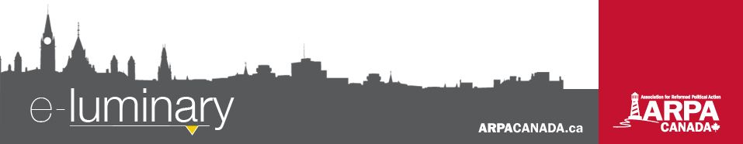
Association for Reformed Political Action (ARPA) Canada: April 2017
Quick Updates:
- Parliament legalized "medical assistance in dying" ("MAID") nine months ago. So far, MAID has been provided without proper monitoring or government oversight. Visit ARPACanada.ca/Bill84 to learn more and to take action.
- M-103, the “Islamophobia motion”, passed 201 to 91 on March 23. ARPA is considering applying to speak at the Heritage Committee on this motion. Stay tuned for updates.
- Ontario’s Bill 96, the Anti-Human Trafficking Act, will (if passed) allow survivors to apply for human trafficking-specific restraining orders and take their traffickers to court. For further analysis and to send an EasyMail in support of this bill, visit ARPACanada.ca/Bill96.
- Last week we released part 7 of our palliative care video series, “Ending Suffering: The Palliative Alternative.” This series has featured interesting conversations with remarkable people: those with extreme disabilities, family members of people with debilitating diseases, and professionals who are there to help. You can view the first seven installments on our YouTube channel (YouTube.com/ARPACanada).
Opposing Bill 89
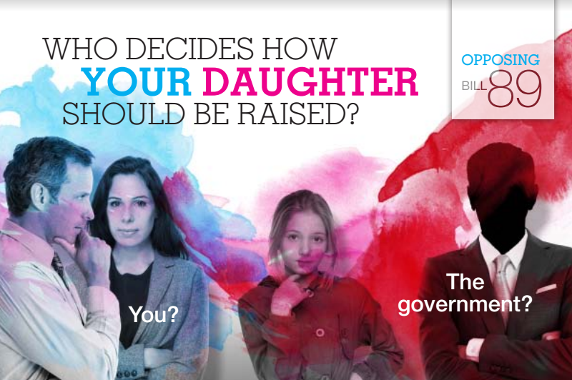
Ontario’s Bill 89 will (if passed) replace the Child and Family Services Act, which governs child protection, foster care, and adoption services and will:
- Give government the power to subject your family to the government’s view of sexual identity and morality

- Require foster and adoptive families to affirm government ideology as a pre-requisite for receiving children into their care

- Undermine parental authority in a child’s religious upbringing

- Increase the potential for children’s aid intervention in family affairs
This bill is cause for serious concern. Neither Bill C-16 or Motion 103 has as much potential to disrupt our families as Bill 89 does.
Ready, set, ACTION!
Take a stand for life and make plans to visit Ottawa on May 11 for the annual March for Life!
Please also join us for our annual prayer service, co-hosted by Jubilee Canadian Reformed Church, the morning of the march (email Hannah at Hannah@ARPACanada.ca for details).
As the Ontario Minister of Family and Child Services, stated, “I would consider that a form of abuse, when a child identifies one way [LGBTQ] and a caregiver is saying no, you need to do this differently.”
Since abuse is grounds for removing a child from a home, you can see where this can lead. For more information, visit ARPACanada.ca/Bill89.
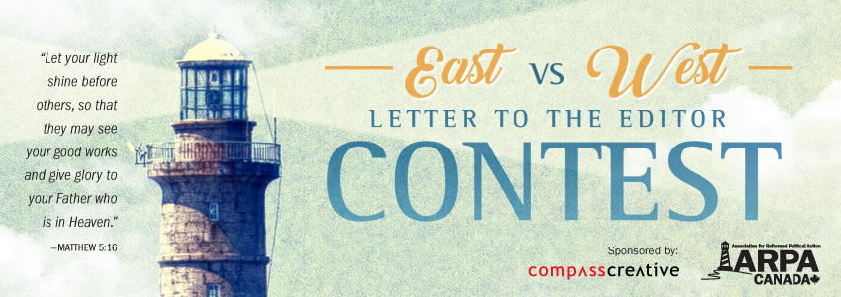
Letter to the Editor Contest
Looking for a challenge? This year we brought back our letter to the editor contest - East vs. West edition! Thanks to our generous sponsor, Compass Creative, we are giving out a $200 Amazon gift card to the winner of each of our five categories:

Everything we do is to be done to the honour and glory of God. We encourage you to join us in prayer as we carry out our mission.
PRAISE:
- For the introduction of Bill 96 in Ontario, a step in the right direction toward ending human trafficking.
PRAYER:
- For protection for families against legislation such as Bill 89 and Bill S-206.
- That the eyes of our elected officials would be opened to the dangers of euthanasia and that they would, at the very least, begin to monitor it carefully.

Praise &
Prayer
1) Best letter in a large paper (e.g. Ottawa Citizen, Vancouver Sun)
2) Best letter in a community paper (city up to 200,000 population)
3) Best letter by someone under age 20
4) Most letters published & submitted to contest
5) One letter picked at random from all entries

Send a link to your letter or a picture of the published letter to info@ARPACanada.ca, or mail it to ARPA Canada, PO Box 1377, Stn B, Ottawa ON, K1P 5R4. Winners will be picked at the end of the year!

Bill S-206: #NOTaCriminal Campaign
A senator has introduced a bill that, if passed, will limit your freedom to parent your children. The bill would remove section 43 from the Criminal Code, which states “a parent is justified in using force by way of correction toward a… child… if the force does not exceed what is reasonable in the circumstances.”

Without section 43, the Criminal Code prohibitions on assault would apply when you spank or even restrain your child. Assault means any unwanted physical contact without consent.

So if S-206 passes, what does that make you? A criminal. We need to work together to stop this bill.

We have three action items for you:

1. Make a 30 second video saying that you’re a parent, that you love your children, that Bill S-206 would make you a criminal, and that it needs to be stopped. Post your video to social media with the hashtags #lovingparent #NOTaCriminal and #stopS206. If you don’t have children, you can still make a video about how your parents lovingly disciplined you.

2. Send a letter to the editor using the same talking points. (If your letter gets published, make sure you submit it to info@ARPACanada.ca for our letter to the editor contest!).

3. If Bill S-206 makes it past the first vote, it will go to the Senate Committee on Legal and Constitutional Affairs. Consider making a written submission and, if you’re up for it, include a request to present to the committee. If you are willing to do so, email info@ARPACanada.ca and we will show you how to make the submission.

Together, we can protect our families and our children. Check out ARPACanada.ca/BillS206 for more details.
“But the one who looks into the perfect law, the law of liberty, and perseveres, being no hearer who forgets but a doer who acts, he will be blessed in his doing.” ~ James 1:25 ~
Contact Us: 1-866-691-2772 | info@arpacanada.ca
Donations can be directed to: ARPA Canada PO Box 1377 STN B, Ottawa Ontario K1P 5R4

