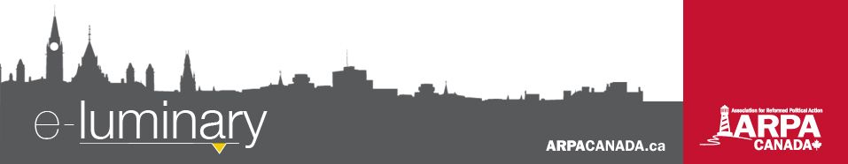
Association for Reformed Political Action (ARPA) Canada: May 2017
Quick Updates:
- Are you part of a “zombie family”? The architects of a major re-write of Ontario's family law think so. Check out ARPA lawyer John Sikkema’s blog post on our website (ARPACanada.ca/blog) for a behind-the-scenes look at recent changes to family law in Ontario.
- Think that only doctors and nurses have to wrestle with how assisted suicide impacts their professions? Check out the latest installments of our Palliative Care series (YouTube.com/ARPACanada) where a seminary professor and a funeral director share perspectives you may not have considered.
Bill 89 Update
This past month we launched an EasyMail campaign urging Ontario MPPs to support the amendments below to Bill 89. Thank you to all of those who responded to this call to action!
1) Nothing in this Act affects:
Ready, set, ACTION!
Be sure to tune in to our weekly podcast at LighthouseNews.ca to stay up to date on current events. Be edified by the news, not frustrated!
a) the constitutional freedoms of conscience, religion, and expression, and in particular the freedom of parents to hold and to teach their children their conscientious or religious beliefs with respect to matters of sexual identity and morality.
2) Nothing in this Part requires a parent or caregiver to:
a) actively affirm or to socially condition a child in a gender identity that is incongruent with the child’s birth sex;
b) facilitate access for a child or young person to medical services that are not medically necessary, which includes puberty inhibitors and cross-hormone treatments as treatments for gender dysphoria; and failure to do so shall not be considered grounds for finding that a child is in need of protection.
ARPA’s legal counsel, John Sikkema, presented to the Committee reviewing Bill 89 this past month and focused on why it is bad public policy to add a long list of personal identifying characteristics (the child’s race, family diversity, creed, sex, sexual orientation, gender identity, gender expression) as matters that must be considered whenever foster and adoption agencies, child protection services, or judges make decisions about a child’s care. You can read more about John’s appearance before this committee at the ARPA blog (ARPACanada.ca/blog). The Committee on Justice Policy is currently reviewing amendments to the bill so stay tuned for an update!
Canada Must Start Monitoring “Medically Assisted Dying”
This past month we launched a campaign for better reporting and regulations around doctor-assisted suicide in Canada. Since Bill C-14 was passed in June (2016), assisted suicide and euthanasia have been permitted and performed without reporting or monitoring.
The Ontario government recently tabled Bill 84, which would require physicians and nurse practitioners to give notice to the coroner whenever “medical assistance in dying” is provided. The Ontario government is right to require physicians to report every “medically assisted” death to the coroner and we commend this initiative. However, Bill 84 does not set out the content of the notice to be given to the coroner. The coroner should be able to determine from the notice, at a minimum, some basic information about the circumstances and the cause of the person’s death.
We must remind MPs and MPPs of the dangers of legalized assisted suicide and euthanasia and of the necessity of “scrupulous monitoring and enforcement.” Visit ARPACanada.ca/Bill84 for details on how you can take action.
20th Annual March for Life!
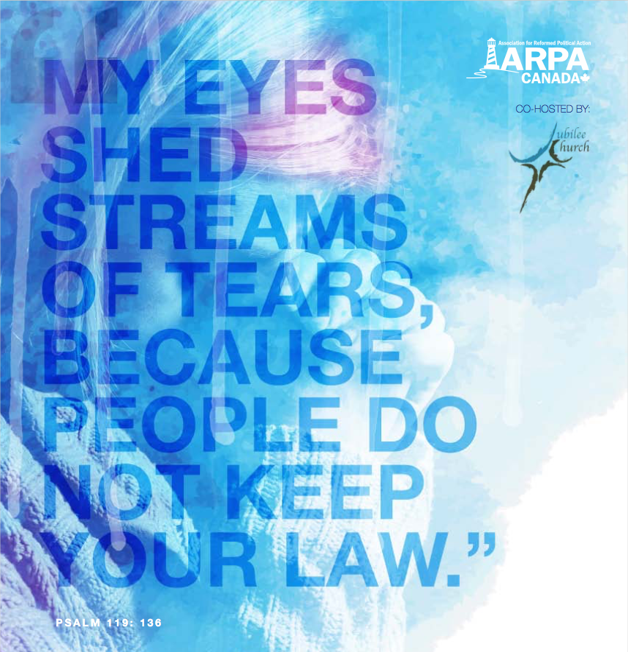
The National March for Life will be held in Ottawa on Thursday, May 11, 2017. A Reformed Prayer Service will be held in Victoria before the provincial march in BC and in Ottawa before the national march. We hope to see you there!
Ottawa Reformed Prayer Service
Where: First Baptist Church (140 Laurier Avenue West)
When: 10:00 am
Victoria Reformed Prayer Service
Where: Central Baptist Church (833 Pandora Ave.)
When: 11:30 am
Following each prayer service there will be bagged lunches for all those who pre-register. After the prayer service, head to the provincial Legislature (Victoria) or Parliament Hill (Ottawa) to join with thousands in speaking up for the most vulnerable in our society. Visit ARPACanada.ca/M4L2017 for more details.
Alberta Education Controversy

Everything we do is to be done to the honour and glory of God. We encourage you to join us in prayer as we carry out our mission.
PRAISE:
- For our faithful donors whose continual generous support enables us to carry out our mission.
- For the addition of Ed Hoogerdyk to the team who will take on the position of Alberta Director, effective the summer of 2018.
PRAYER:
- For the safety of those who will be participating in a March for Life and that this may be an effective tool in uniting Canadians to stand up for pre-born human rights.
- For the students travelling to Ottawa for our upcoming God and Government Youth conference.
Praise &
Prayer
There has been a lot of controversy with the Alberta education system over the past month. It all began when a government-sponsored website run by the Institute for Sexual Minority Studies and Services (iSMSS) shared internet links to sexually explicit materials, which were supposedly resources intended to help kids with their GSA (Gay-Straight Alliance). ARPA interviewed Theresa Ng who runs a site called “Informed Albertans”, where she blogged about her discovery of these materials. She says there is a deeper concern at play here as Alberta is undergoing a rewrite of the curriculum, which she suspects the iSMSS is involved in.
Theresa is asking parents across Alberta to write to Education Minister David Eggen, to demand public assurances that those responsible for offering this sexually graphic material to children are not still being entrusted with influence over the curriculum rewrite, educational resources and teacher training.
She is hoping to deliver these letters in person by May 5, so please send yours to PO Box 92131 Meadow Brook, Edmonton, AB T6T 1N1. For more information, visit her blog at informedalbertans.wordpress.com.
ARPA also started an EasyMail campaign in response to Minister Eggen’s lashing out against a Reformed pro-life girl who gave a presentation at a Catholic high in which she compared the dehumanization of pre-born children today with the dehumanization of the Jews in Nazi Germany. The Minister referred to this as “hateful propaganda” that should not be tolerated in Alberta schools (just weeks after the GSA controversy outlined above).
ARPA is urging Alberta supporters to take action by sending an EasyMail or letter to the Alberta Education Minister. EasyMails are available at Easy.ARPACanada.ca.
“Let your light shine before others, so that they may see your good works and give glory to your Father who is in heaven.” ~ Matthew 5:16 ~
Contact Us: 1-866-691-2772 | info@arpacanada.ca
Donations can be directed to: ARPA Canada PO Box 1377 STN B, Ottawa Ontario K1P 5R4

