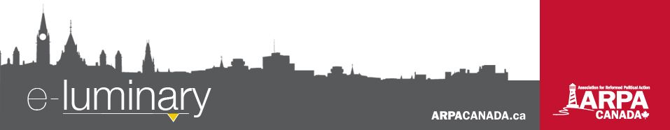
Association for Reformed Political Action (ARPA) Canada: July 2017
Quick Updates:
- Bill 89 is now law in Ontario, with 23 MPPs voting against it. Visit ARPACanada.ca/Bill89passes for more information and to send your MPP a note.
- Bill C-16 also passed into law this past month, adding gender identity and expression to federal law.
- We have completed the paperwork required to ask the Supreme Court for “intervenor status” in the Trinity Western case. Stay tuned for updates!
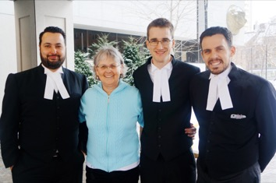
FIPPA Victory
In the spring of 2015, ARPA Canada and pro-life blogger Pat Maloney took the Ontario government to court because the government, through a new law, was censoring all abortion-related information. They were hiding how much tax dollars the government spent on abortion and how many pre-born children were being killed. Our day in court was February 1st of this year and on June 9 we received the judge's ruling. We won! Praise the Lord!

We especially want to thank Pat Maloney whose work and research is invaluable to the prolife movement and for her patient persistence leading up to the trial. We also want to thank Albertos Polizogopoulos and John Sikkema, the legal team who championed our cause in court. And of course, we thank you, our supporters, for your prayers, encouragement and support. To God be the glory!

We were very thankful to discuss this victory with a number of media outlets, including the Ottawa Sun, CBC Radio 1, The Andrew Lawton Show, and The World and Everything in It, and were also quoted in articles by the Ottawa Citizen, LifeSite News, the Catholic Register, and more.

The Ontario government has 12 months to put remedial legislation in place before the current law becomes invalid, so stay tuned for updates!
Motion 47 Report Needs to be Reassessed
Ready, set, ACTION!
This summer, take time to meet with your MP while s/he is in your riding. Use this time to build relationships that will continue throughout the year!

Parliament’s Health Committee has tabled its report on the public health effects of graphic online pornography. The Committee spent several months this spring hearing testimonies on the issue, after the House unanimously passed a motion introduced by MP Arnold Viersen calling for such a study. However, the report is a huge disappointment, as it got sidetracked on the issue of gender identity and sexual expression.

The only recommendation the committee made was to pass the job off to the provinces with more sexual education curriculum. The report entirely ignores the contribution of violent pornography to violence against women and the impact of constant exposure to such pornography on the psyche of the user, whether adult or child. The government seems to think they have no responsibility in protecting our children from viewing violent, degrading, and dehumanizing acts online.

Please contact your representative today, asking them to challenge the government on this report. Visit Easy.ARPACanada.ca for access to our EasyMails.
Will Bill C-51 Permit Protests in Church Services?
Did you know that Canada’s Criminal Code (section 176) prohibits obstructing a “clergyman or minister” from “celebrating divine service or performing any other function in connection with his calling” or disturbing “an assemblage of persons met for religious worship”? That prohibition might not be there for long. A new government bill, Bill C-51 (which has passed second reading and been referred to committee), would delete these prohibitions from the Code. If this bill passes, what will it mean for the legal protection of churches and ministers?
Check out our blog!
Did you know we have a blog? It’s where our staff offer personal reflections and opinions on current social and public policy issues.
Our latest blog post by our Director of Law and Policy is in reaction to an Ontario Government ad which sends the message that kids are annoying, so make sure you use birth control!
Visit ARPACanada.ca/blog to read it in full and to browse our blog archives!
The removal of this provision will not allow assaults on ministers or violent protests in temples, but the question is how it will impact borderline instances. What about the disgruntled individual yelling as the service starts? Or the protesters who bring offensive signs outside a mosque? When do these activities cross a line into becoming disturbances? Bill C-51 would remove the explicit direction to judges to take the particular setting into account.

The benefit of having section 176 is that it makes clear that protection of assemblies is beneficial. It sends a message that communities should be able to gather for religious, social or moral purposes without fear of disruption either from individuals or disagreeing communities. As Canada welcomes more people of diverse faiths and conversations around controversial cultural issues increases tension, it is likely that we will have greater need for section 176, not less, in the coming decades.

Please send your Member of Parliament a note of concern, urging amendment to Bill C-51, by visiting Easy.ARPACanada.ca.

Everything we do is to be done to the honour and glory of God. We encourage you to join us in prayer as we carry out our mission.
PRAISE:
- For the judge’s favourable ruling in our FIPPA case!
PRAYER:
- For Christian schools in Canada, such as Cornerstone Christian Academy in Edmonton, which are being ordered to refrain from studying “offensive” scripture.
- That our applications to intervene in the TWU and Wall cases would be accepted.
- That the Motion 47 report released by the Health Committee would be reassessed.
Praise &
Prayer
“Safe” Injection Sites Now Legal across Canada
“Safe” or “supervised” injection sites provide drug users with clean needles and medical supervision for injecting narcotics. Parliament made it a lot easier to establish safe injection sites with the passing of Bill C-37 in May. Canada’s Health Minister is currently reviewing 19 applications for such sites, and more applications are expected.

Supervised injection facilities, which are still quite rare, aren’t the only “harm reduction” tool in use. Needle exchange programs (NEPs) have been operating for years in many cities and towns in Canada. In Ontario alone there are well over 200 locations providing injection drug users with free sterile needles; over 35 of those are in Toronto. These programs have, studies claim, helped to significantly reduce the spread of infections (through sharing and re-using needles).

But could needle exchange programs, safe injection sites, and now even “heroin-assisted treatment”, “managed alcohol programs” and the like – in which the substance is also provided to the user – have long term effects that are more difficult to measure? Could growing acceptance of an addict-as-helpless-victim mindset ultimately be more deadly than a shortage of safe injection sites?

Send us your thoughts at info@ARPACanada.ca and pay attention to local developments and opportunities for involvement and ministry in your community.

“And let us not grow weary of doing good, for in due season we will reap, if we do not give up.” ~ Galatians 6:9 ~
Contact Us: 1-866-691-2772 | info@arpacanada.ca
Donations can be directed to: ARPA Canada PO Box 1377 STN B, Ottawa Ontario K1P 5R4

