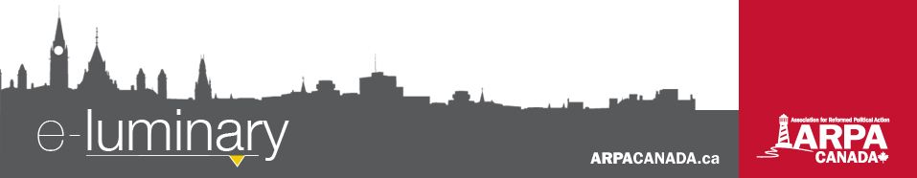
Association for Reformed Political Action (ARPA) Canada: September 2017
Quick Updates
- We have received intervener status for two Supreme Court cases later this year! Details on reverse.
- Help us bring God’s Word to every MP, Senator, MPP and MLA in Canada! Visit ARPACanada.ca/BibleProject for more information. We are still short $9,000 of the total cost. Donations can be made online or at the address at the bottom of this newsletter.
- Western Canada is far ahead of Ontario and the East in our letter to the editor contest. Writing a letter is free and can have a big impact. We can help you with yours. Visit ARPACanada.ca/L2E for more information.
Fall Tour 2017 – Who is Sovereign?
Would you be okay with a judge telling the elders of your church how to exercise church discipline? Would you be okay with the premier telling you how to raise your kids? It is beginning to happen. And it doesn’t stop there.

The Supreme Court will hear a case to decide whether they have the power to overturn church discipline. Laws continue to be introduced limiting how parents educate, discipline and raise their children. How should we respond?

Please join us for our annual speaking tour as we present in 20 cities across BC, Alberta, Saskatchewan, Manitoba and Ontario from September 25 to October 20. All events are free and we encourage youth and adults (including bible study groups and catechism students) to attend this informative and timely presentation.

In order to better anticipate how many people to expect, and to avoid a line up out the door the night of the event, we have added our events to Eventbrite which allows you to pre-register and bring your ticket to the event to skip the line. To do so, visit ARPACanada.ca/FT17RSVP, and don’t forget to let us know if you’re attending on Facebook!
All events are from 7:30 – 9:30 p.m.

East (André Schutten and Colin Postma) |  |  | West (Mark Penninga and John Sikkema)
September 25 | Redeemer Canadian Reformed Church (Winnipeg) |  | October 10 | Emmanuel Free Reformed Church (Abbotsford)
September 26 | Thunder Bay United Reformed Church |  | October 11 | Cloverdale Canadian Reformed Church
September 27 | Covenant Reformed Church of Toronto |  | October 12 | Vernon Canadian Reformed Church
September 28 | Providence Reformed Collegiate (Komoka) |  | October 13 | Regina Christian School
September 29 | Oxford Reformed Christian School |  | October 16 | Coaldale Canadian Reformed Church
October 2 | Maranatha Free Reformed Church (Hamilton) |  | October 17 | Calgary Free Reformed Church
October 3 | Living Hope Free Reformed Church (Chatham) |  | October 18 | Redeemer United Reformed Church (Lacombe)
October 4 | Riverside ARP Church (Cambridge)  *Avenue Road Baptist Church building* |  | October 19 | Immanuel Canadian Reformed Church (Edmonton)
October 5 | Emmanuel Canadian Reformed Church (Guelph) |  | October 20 | Neerlandia Canadian Reformed Church
October 6 | Heritage Christian School (Jordan)
October 17 | Ottawa Reformed Presbyterian Church

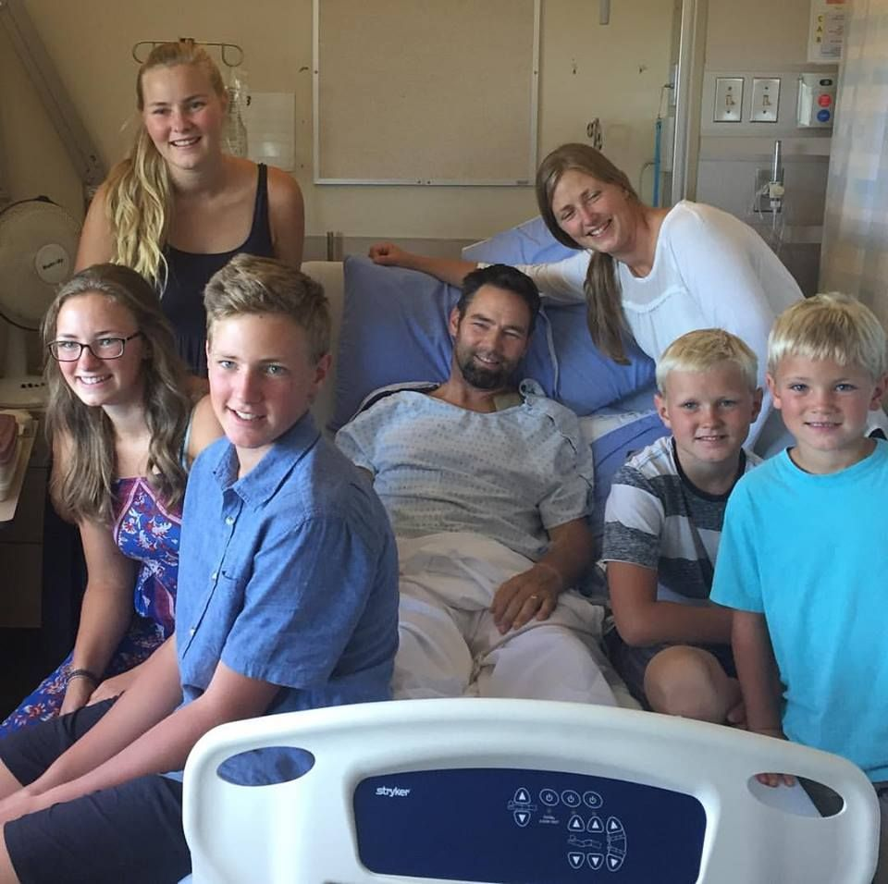
Update on Mike Schouten
On August 24th, our friend and colleague Mike Schouten, director of WeNeedaLAW, was involved in a serious collision. Mike was hit by a truck while cycling in the Bulkley Valley.
We are very thankful that God spared his life, kept his mind sharp and strong, and provided Mike with excellent medical care. He has undergone successful surgery on his fractured pelvis and broken shoulder. Although Mike is in pain and it will be a long road to recovery, we are also very thankful that it appears that recovery is possible and he will be able to resume his work in time.
We ask you to please keep Mike and his family in your prayers now and in the weeks to come.
In light of his injuries and need for long-term rehabilitation, speaking engagements, trips, and projects specific to Mike that were planned for the next couple of months will be delayed, cancelled or postponed. It is unclear at this point when these will be resumed.
Mike, surrounded by his wife and all but one of his children after coming out of surgery
We ask for your patience during this time of healing. If you have specific questions about the impact on a project or event you may be involved with, please direct them to Mike’s assistant Alicia Ibbitson who can be reached at alicia@weneedalaw.ca.

Everything we do is to be done to the honour and glory of God. We encourage you to join us in prayer as we carry out our mission.
PRAISE:
- For receiving intervener status for the TWU and Wall cases!
- For the many active ARPA school clubs that encourage political action among our young people.
PRAYER:
- For patience and strength for Mike Schouten and his family on his road to recovery over the coming weeks.
- For safety for Members of Parliament and provincial representatives who are returning to their offices this month, and that they may be responsive to our concerns.
Praise &
Prayer
ARPA at the Supreme Court of Canada
With thankfulness to God we are excited to announce that we have received intervener status for both the Trinity Western University and Wall v Jehovah’s Witnesses Congregation cases later this year!

The Wall case is about whether civil courts have authority to review church discipline or church membership decisions. While the case involves a Jehovah’s Witnesses Congregation, it has major implications for Christian churches. At the hearing on November 2, we will bring a Reformed confessional perspective to the Court and argue that the supremacy of God and the rule of law - two fundamental constitutional principles - demand that the courts not interfere with the exercise of the keys of the kingdom. For more information, visit ARPACanada.ca/wall-update.

In the TWU hearing on November 30th and December 1st, we will argue that all Canadians are guaranteed access to the public square without discrimination on the basis of religion. This case will have profound effects on religious freedom in Canada. For more information, visit ARPACanada.ca/twu-update.

Please continue to pray for our Law and Policy team as they make preparations for both of these court cases, that their arguments would effectively defend religious freedom and the independence of the church from the state in Canada.

“Give thanks to the Lord, for He is good; His love endures forever.” ~ Psalm 118:29
Contact Us: 1-866-691-2772 | info@arpacanada.ca
Donations can be directed to: ARPA Canada PO Box 1377 STN B, Ottawa Ontario K1P 5R4

