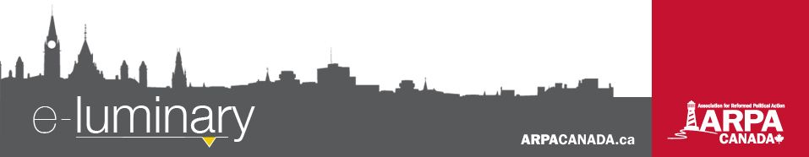
Association for Reformed Political Action (ARPA) Canada: November 2017
Quick Updates
- The Alberta government has introduced Bill 24 (“An Act to Support Gay-Straight Alliances”) which threatens to shut down Christian schools by mandating things we simply cannot do because of our faith and commitment to serving the Lord. Visit StopBill24.ca to take action.
- We are in month 2 of our 12 step action plan! The goal this month is to introduce yourself to the government representative you selected last month. Visit ARPACanada.ca/12steps for more info.
Equipping Young & Old: Fall Tour 2017
We recently wrapped up our annual fall tour, where we were blessed to see many of you. This year we expanded it to four full weeks, and split that between two teams. Mark Penninga and John Sikkema went through Western Canada and André Schutten and Colin Postma focussed on Ontario and Manitoba.
By the end of the whirlwind tour we made 21 presentations to churches and another 21 to schools. This directly reached close to 3,000 people in a span of about 4 weeks.
After the presentation, we sent out a survey. This is what some of the attendees had to say:
- “I enjoyed it. I tend to avoid politics but this was eye opening for me that we can’t just stand by.”
- “It was professional, clear, and well communicated. I’m thankful for an organization that seeks to use its resources and donations in the most effective way possible – always pointing to our need of divine guidance and blessing.”
- “I was very impressed with the Gospel-centeredness of the presentation.”
- “It really put me back on track to helping my country.”
And about 70% of those surveyed also said they planned to follow our 12-Step Action Plan to build a relationship with a local government official over the next year. We look forward to seeing hundreds of relationships formed, building a foundation for long-term proactive engagement.
ARPA at the Supreme Court
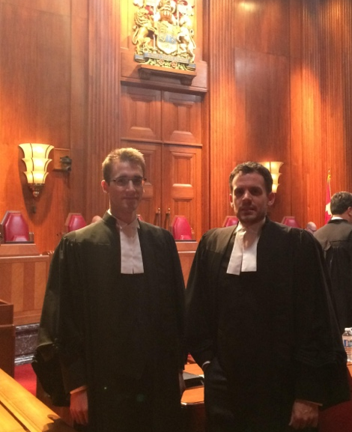
We are intervening in two Supreme Court of Canada cases this month that will have a big impact on the freedom of churches, schools, and Christian organizations, for better or worse. On November 2nd, our Legal Counsel John Sikkema (pictured left, standing to the left of André Schutten) appeared before the Court in the Wall case, where the central question is whether a secular court has the authority to overturn a church’s decisions on matters pertaining to discipline and membership. As we explained in our fall tour, the wrong decision from the Court will set a precedent that will impact the freedom of all churches to administer the keys of the kingdom of heaven.
We brought a uniquely Reformed perspective to the Court. Since Reformed churches not only have a rich theological heritage on this issue, they also faithfully make use of church discipline. It was neat to see one of the judges, at the hearing, ask a question of the other lawyer while referencing the Belgic Confession, which John had introduced minutes earlier.
At the end of this month, our Director of Law and Policy André Schutten is scheduled to appear before the same court in the Trinity Western University law school case. As many of our readers know, we have intervened in the lower levels of this case in BC, Nova Scotia, and Ontario. Although TWU has a very strong case, many in the legal community have been ignoring the law, clearly bent on imposing their own ideology on this nation. As we explained on our tours in years past, the outcome will not only affect TWU; it will impact all Christian organizations that govern themselves according to Christian conduct.
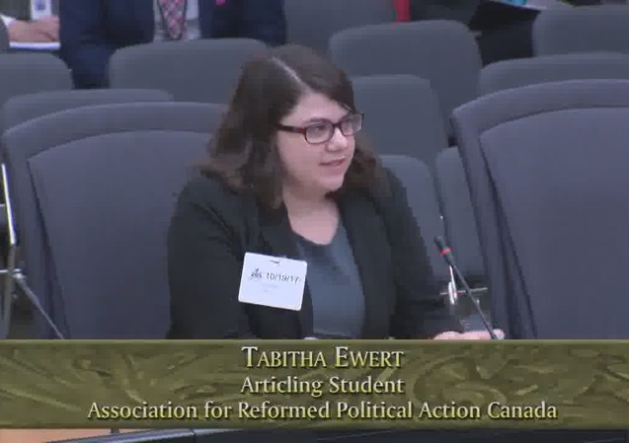
Ontario Government censors one side of abortion debate
In October the Ontario government introduced and passed Bill 163 (Protecting a Woman's Right to Access Abortion Services Act) which prevents any pro-life messaging around abortion clinics, hospitals, and abortionists’ homes.
When ARPA Canada applied to present our concerns to a legislative committee, we were approved. We provided an extensive legal analysis showing how the bill was unconstitutional and sent Tabitha Ewert, our articling student, to present to the legislative committee that studied the bill (pictured right).
The fact that the province pressed ahead with the bubble-zone law regardless, and the opposition PC party gave their support, is disappointing. But it is also a reminder that we live in an age where we can’t expect our leaders to stand up for justice and freedom. We need to be the ones witnessing to the truth, wherever God has put us.

Everything we do is to be done to the honour and glory of God. We encourage you to join us in prayer as we carry out our mission.
PRAISE:
- For another successful fall tour!
- For the outpouring of support from our grassroots to keep section 176 of the Criminal Code, right when we needed it most!
PRAYER:
- For travelling mercies and wisdom for our volunteer Board members at their upcoming meeting in Ottawa.
- For the Trinity Western University hearings on November 30 and December 1.
- For wisdom for Christian schools, parents, and school boards as they grapple with this latest interference in the education of their children.

Praise &
Prayer
Parliament keeps criminal law protections for religious worship
On November 8th a Criminal Code protection for religious worship services was saved from the chopping block. The House of Commons Standing Committee on Justice and Human Rights voted in favour of an amendment to Bill C-51 in order to keep section 176 of the Criminal Code.
Members of the Justice Committee from all parties referenced an outpouring of support for the section, particularly in the week leading up to the decision. We can say with some certainty that the vast majority came from you, our ARPA supporters. Many religious leaders, including our Director of Law and Policy, André Schutten, had presented to the committee, urging the members to keep the section, with slight amendment.
In a time of growing tension in Canada around the place of religion, section 176 was an important section to keep. Schutten was a co-signor of an interfaith letter, delivered to the Justice Minister on October 31st, urging her to keep the provision. 66 faith leaders signed on, representing Sikh, Jewish, Muslim, Buddhist, Catholic, Orthodox and Protestant religious traditions.
Thank you all so much for engaging on this important file!

“Your righteousness is righteous forever and Your law is true.” ~ Psalm 119:142
Contact Us: 1-866-691-2772 | info@arpacanada.ca
Donations can be directed to: ARPA Canada PO Box 1377 STN B, Ottawa Ontario K1P 5R4

