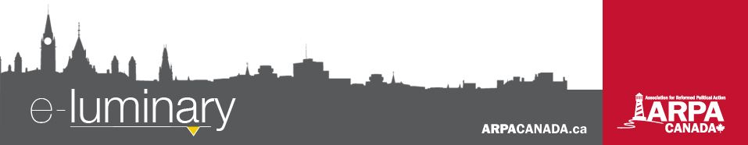
Association for Reformed Political Action (ARPA) Canada: December 2017

Quick Updates
- Canada’s government is well on its way to legalizing marijuana. Is this policy change based on a false narrative? Are there still ways to deter marijuana use? Check out our latest blog at ARPACanada.ca.
- We have a new policy report on in-vitro fertilization. You can access it on the “Publications” tab on our website under Resources. Take a read and send us your thoughts at info@ARPACanada.ca.
- Tune in to LighthouseNews.ca on Tuesday, December 19, for our final episode of 2017. Our host, Al Siebring, will provide a year in review, highlighting all of the big news stories of 2017. You don’t want to miss it!
Alberta Education - Bill 24
Bill 24, “An Act to Support Gay-Straight Alliances” passed third reading on November 15th, less than two weeks after being tabled. This bill parents are a detriment to the wellbeing of their own children and threatens to shut down Christian schools, and other faith-based schools that do not adopt the required policies regarding gay-straight alliances.
Like you, we too were disappointed that the Alberta government passed Bill 24. However, we are so thankful for the impact that all of you have had on the final vote!
Ready, set, ACTION!
We are in month 3 of our 12 step action plan! The goal this month is to handwrite a Christmas card to your selected government representative.
Visit ARPACanada.ca/12steps for more information.

Here are a few numbers:
- Dozens of supporters stepped up to fund over 400 radio ads directing people to www.stopbill24.ca
- 3,200 emails were sent to MLAs – a new ARPA record!
- 7,000+ visits to www.stopbill24.ca
- 100,000+ people reached through social media advertising
And all of this within the span of only one week!
We are so thankful for this incredible response and we praise God for your willingness to engage, for understanding the significance of this bill, and for having the courage to speak out against it.
Please do not be disheartened. We may not know what impact all of your political action will have, but we do know that our God is much bigger than this and He is in control – also of the hearts of those who govern over us (Proverbs 21:1).
The conversation surrounding Bill 24 is not over. ARPA’s Law & Policy team is working with other stakeholders in Alberta to map out a legal strategy, and we will be working with parents and schools as they navigate this new legal landscape.
ARPA at the Supreme Court: Trinity Western University
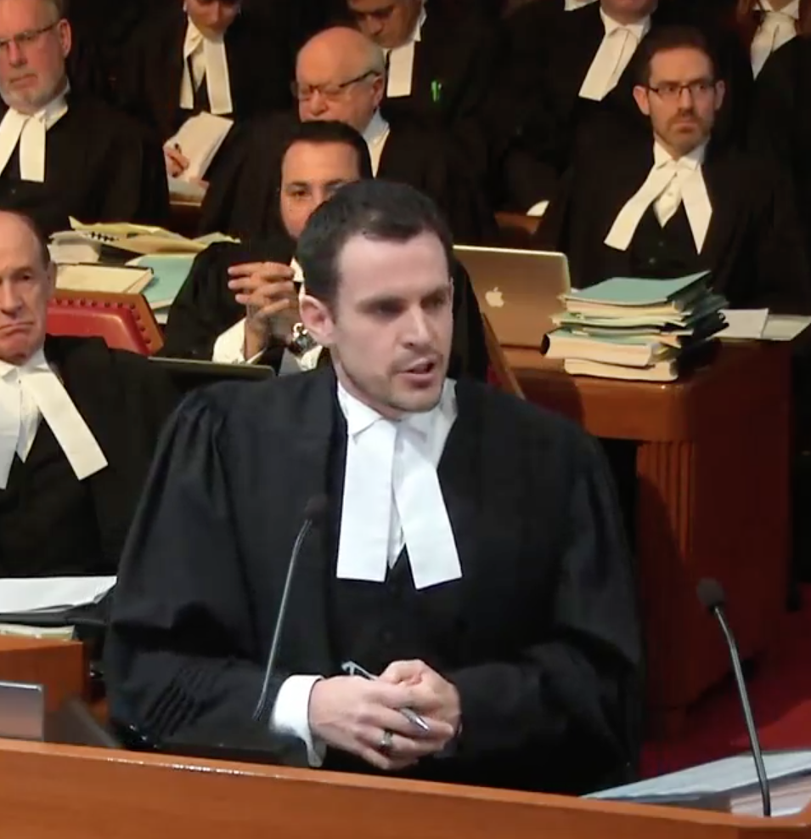
On December 1st, our Director of Law and Policy André Schutten appeared before the Supreme Court in the Trinity Western University law school case. In his allotted 5 minutes, André argued that Trinity Western does not violate Charter equality rights of its students, but that the law societies do violate the equality rights of Trinity Western graduates. He emphasized that we need to distinguish between association and discrimination. You can visit the ARPA homepage (ARPACanada.ca) to watch André’s remarks in full.
Want to know what happened over the two-day hearing but don't have the time to sit and listen to hours of the recordings? Our Law and Policy team sat down for a debrief following the hearing to discuss the history of the case, a summary of the arguments from both sides, and the implications of the case going forward. You can find this video on our Facebook page, or request a link to see it by emailing info@ARPACanada.ca.
We also highlighted the various arguments from both sides of the case on a recent Lighthouse News podcast (December 5). In just 20 minutes, you can hear the key arguments, the questions from the Justices (along with the lawyers’ answers) and get a sense of how the hearing went. Visit LighthouseNews.ca.
Progress on Palliative Care

Everything we do is to be done to the honour and glory of God. We encourage you to join us in prayer as we carry out our mission.
PRAISE:
- For the unanimous support for Bill C-277, a step in the right direction to ensuring all Canadians have access to quality end of life care.
- For God’s grace in guiding us through another year and for your continued support of ARPA’s work and mission!
PRAYER:
- For the attack on Christian and faith-based schools with the passing of Bill 24 in Alberta.
- For travelling mercies for staff and their families over the Christmas holidays.
Praise &
Prayer
Bill C-277, the “Framework on Palliative Care in Canada Act”, first put forward as a private member’s bill by Sarnia-Lambton MP Marilyn Gladu, received unanimous support in both the House of Commons and Senate and received Royal Assent on December 12th. The bill calls for the development of a national palliative care strategy.
Meanwhile, Sam Oosterhoff, MPP for Niagara West-Glanbrook, has introduced a private member’s bill called the “Compassionate Care Act”, which calls on the Minister of Health to provide better hospice care in Ontario. He says when the legislature debated a framework for doctor-assisted suicide, there was a general recognition that the province also needed improved palliative care services.
Ontario has a chronic shortage of hospice beds. There are 341 hospice care beds, when it needs more than 1,300 based on the population.
Oosterhoff’s bill would require the health minister to report to the Legislature within six months of the bill passing, and then follow up with updates on any recommendations made in that report. The bill has the support of the Ontario Medical Association and the Registered Nurses Association of Ontario.
Visit ontariopalliativecare.ca for more details.
Wishing you and your family a joyous Christmas and blessings in the coming year!
“For God so loved the world, that He gave his only Son, that whoever believes in Him should not perish but have eternal life.” ~ John 3:16
Contact Us: 1-866-691-2772 | info@arpacanada.ca
Donations can be directed to: ARPA Canada PO Box 1377 STN B, Ottawa Ontario K1P 5R4

