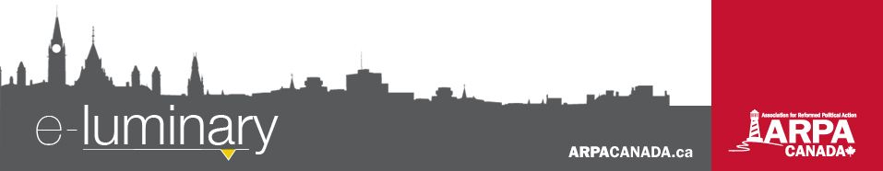
Association for Reformed Political Action (ARPA) Canada: February 2018

Quick Updates
- We are still accepting applications to our God& Government conference in April! The deadline for applications is March 17. We received confirmation that Pastor Douglas Wilson will be the keynote speaker at the banquet on Thursday, April 19 (which we are selling separate tickets for if you are unable to attend the whole conference). Visit ARPACanada.ca/GG18 for more information and to apply.

- The “Ontario Safe Access to Abortion Services Act” came into effect on February 1, making it an offence, punishable by fines and prison, to “attempt to advise” someone to refrain from having an abortion, or “inform a person concerning issues related to abortion services”, if the attempt is made within 150m of an abortion clinic. Read our most recent blog post at ARPACanada.ca for more details.
Ontario healthcare is sick – we need your help addressing it
Member of Provincial Parliament Sam Oosterhoff put forward the Compassionate Care Act (Bill 182) in the Ontario legislature last fall. Currently the bill has passed second reading and has been referred to committee.
The Compassionate Care Act is a step to ensure that palliative hospice care is an option for more Ontarians. It requires the Minister of Health and Long-term Care to develop a provincial framework to promote palliative hospice care in Ontario’s health care system through education, training, research and facilitating access.
No patient should feel their only choices are enduring a long uncomfortable stay in a hospital or prematurely ending their life. Palliative hospice care allows the patient to live in relative comfort with the support of palliative care providers.
Help ensure this bill is passed by completing the following action items:
- Visit ontariopalliativecare.ca/write-to-your-MPP to write the Premier and the Government House Leader to ensure this bill is considered and passed before the provincial election.
- Visit ontariopalliativecare.ca/share-your-story to share how hospice palliative care impacts your family.
Connected with this issue is a troubling decision by the Ontario Superior Court last week. The court found that it’s reasonable to force Christian doctors to refer their patient for doctor-assisted suicide. We have an article on that disappointing decision and what it means for you, me and Christian doctors and nurses in this province at ARPACanada.ca/CPSO-decision.
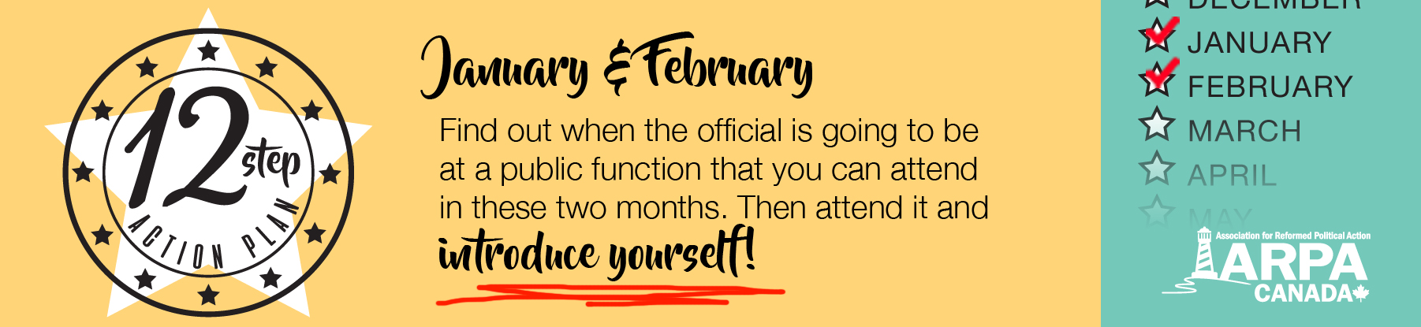
After reading it, commit to making conscience rights a ballot issue for you in this spring election.

We are hiring!

Everything we do is to be done to the honour and glory of God. We encourage you to join us in prayer as we carry out our mission.
PRAISE:
- For the interest shown in our God and Government conference so far!
- For the introduction of Bill 182 – a step in the right direction to ensuring all Ontario residents have access to quality palliative hospice care.
PRAYER:
- That the Lord would provide suitable candidates for our Webmaster, Developer and Video Editor job opening.
- For Ontario doctors’ and nurses’ freedom to practice healthcare in accordance with their conscience.
Praise &
Prayer
We are pleased to announce that we are hiring again! The ideal candidate(s) will be responsible for furthering ARPA’s mission by managing our websites and information technology, producing videos, and developing tools that will equip our constituents with the means to be an effective salt and light. He or she will have a passion for using technology to maximize the quality and reach of ARPA’s resources and activities.

We are open to filling this position with more than one person. If you have skills in just some of these areas, we would still encourage you to apply. The deadline for applications is February 26th.

To apply, please submit:

- a resume/portfolio and an accompanying cover letter
- the names of three people who we can contact as references, one of whom is a character reference;
- your requested compensation and the amount of time you can provide (weekly);
- and a brief personal statement of faith

If you have your own business and are interested in fulfilling parts of the job description as a contractor, please send an email that details what services you can provide, the amount of time you can provide, the compensation required, and a portfolio/resume detailing your experience.

Please send these to ARPA’s Executive Director Mark Penninga at Mark@ARPACanada.ca.

For more details and for the full job description, visit ARPACanada.ca.

BC action item: voting on how to vote
The Electoral Reform Referendum 2018 Act, passed in the fall of 2017, requires that a referendum respecting proportional representation voting system be conducted by mail-in ballot no later than November 30, 2018.
This means for the third time in the past fifteen years, British Columbia is going to vote on whether to ditch the First Past the Post voting system in favor of some form of proportional representation. The Act does not state what question will be asked in the referendum, nor does it prescribe a form for the question. That will be decided in the coming months.
Take Action: You have the opportunity to shape that discussion by filling out the BC Government’s questionnaire before February 28th. They want to know what British Columbians think about the various systems they are putting forward and how the referendum should be conducted. Once you decide what is important to you in this discussion, take the questionnaire. Choosing a voting system will drastically change the way our government works and it’s important that we participate in the process.
Visit ARPACanada.ca/BC-electoral-reform for more information.

“For the word of the Lord is upright, and all His work is done in faithfulness. He loves righteousness and justice; the earth is full of the steadfast love of the Lord.” ~ Psalm 33:4-5
Contact Us: 1-866-691-2772 | info@arpacanada.ca
Donations can be directed to: ARPA Canada PO Box 1377 STN B, Ottawa Ontario K1P 5R4

