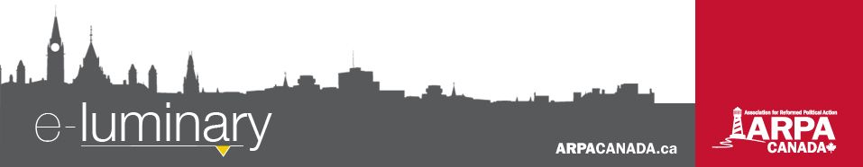
Association for Reformed Political Action (ARPA) Canada: March 2018

God & Government – why come?
After God and Government 2016, we received great feedback from our 90 attendees. They shared what their motivation was to attend, if they would recommend it to others and how they felt the conference went in general. Below are some of the responses:
“The themes and issues were excellent and helpful.”

“Thanks for running it so professionally and for your organization. I really have no words that can fully express my gratitude. God bless you.”

“It was encouraging and gave me the nudge I need to go home and create a better relationship with my MP.”

“It was a fun opportunity to get out of a small town and a good learning experience to go to those type of events. It promotes leadership which is good for heading out of high school. I would 100% recommend this event to others.”

“The meetings [with MPs] were definitely worth the time and effort. I think this should be emphasized and encouraged to the greatest extent possible.”

“Very enjoyable. A wonderful way to be informed and encouraged in the rich promises of God’s Word.”
.

.

“You all did a very good job organizing and it definitely motivated me to do more action!”

.

.

“I came to learn how to become more politically involved. It’s important to learn how to do so from a Christian perspective, so thank-you! Would definitely recommend to others.”

“Thanks for a wonderful time. It is always great to be surrounded by sincere believers with a common goal of reforming our country and encouraging Christian MPs.”

The deadline for applying to this year’s conference is March 17. This conference isn’t just for political junkies or aspiring lawyers. It is designed for the every-day Christian who wants to be an effective voice for truth and justice in whatever situation God has placed you. We highly encourage you to apply or, if you aren’t able to come, to encourage someone else to apply.
Still not sure you’re the right fit? Nervous about what you would say to a politician? Don’t be. We will be with you every step of the way to answer your questions, provide talking points and train you on how to interact with elected representatives. You won’t be disappointed!
Visit ARPACanada.ca/GG18 for more information and to apply.
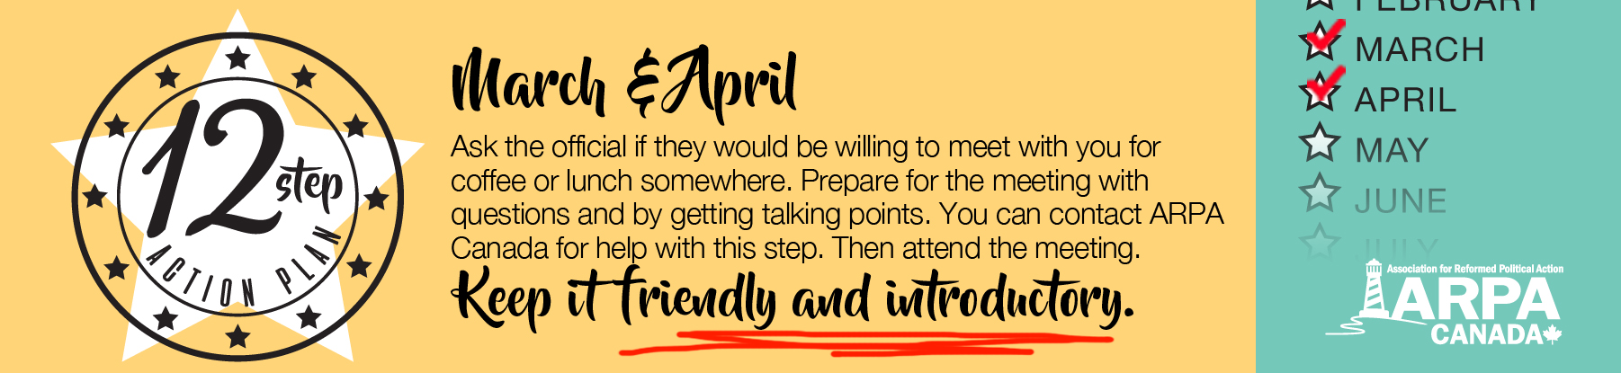

Everything we do is to be done to the honour and glory of God. We encourage you to join us in prayer as we carry out our mission.
PRAISE:
- For the leadership of local ARPA chapters in providing a strong response to local issues.
PRAYER:
- For the success of our sixth bi-annual God and Government conference.
- For the protection of religious liberty in Canada.
- That our elected officials and health care providers would take a stand against the expansion of euthanasia.
Praise &
Prayer
#SaveMyHospice
Fraser Health recently mandated that palliative care providers and hospices must offer euthanasia to their patients. This means that organizations devoted to caring are now being compelled to assist with suicide.
In response to this directive, Langley ARPA organized an event in just three days and had over 300 people attend! ARPA Fraser Valley East decided to organize its own panel of MPs, MLAs and health care providers to discuss the issue, which was also very well attended.
We are thankful for the leadership of our local chapters in providing a strong response to this directive. But we can’t let the conversation end here!
We have two EasyMail letters for you to send to local representatives as well as Fraser Health directors, available at Easy.ARPACanada.ca.
Only the Lord knows whether your actions will result in Fraser Health reversing their decision. In the meantime, out of love for our neighbours, we must warn them that what they are doing will have long term impacts on those in palliative care, their loved ones, and those who care for them.
Manitoba court insists Christian marriage commissioner marry same-sex couples
The highest court in Manitoba has issued a ruling in a case involving same-sex marriage. The court concluded that civil marriage commissioners have no constitutional recourse if the government forces them to perform same-sex ceremonies. The case involves a man named Kevin Kisilowsky who works with street people and gangs in downtown Winnipeg as part of a street ministry. In the course of this ministry, Kevin would encounter people who – because of conviction – decided that they should get married. Kevin found himself in a position to be officiating these services, but he was having to have somebody else come in to do the legal part, so he got his licence to perform weddings in 2003.
Kevin told the government upfront that he was comfortable only doing Christian services, that he didn’t want to marry Wiccans or Hindus or atheists. He was put on a private list and his name was kept out of general circulation. The Manitoba government was fine with this arrangement. There was no conflict between Kevin’s rights and the rights of Wiccans or Hindus or atheists.
However, that all changed the following year, when same-sex marriage became legal. On the day that decision was made, all the marriage commissioners in the province were instructed that they must begin to marry same-sex couples. They got rid of the private list that Kevin was on and threw all the people who were on the private list into the public list… Listen to our latest podcast at LighthouseNews.ca for the full story.

“Blessed be the God and Father of our Lord Jesus Christ, the Father of mercies and God of all comfort, who comforts us in all our affliction, so that we may be able to comfort those who are in any affliction, with the comfort with which we ourselves are comforted by God.”

~ 2 Corinthians 1:3-4

Contact Us: 1-866-691-2772 | info@arpacanada.ca
Donations can be directed to: ARPA Canada PO Box 1377 STN B, Ottawa Ontario K1P 5R4

