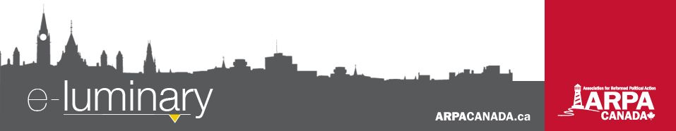
Association for Reformed Political Action (ARPA) Canada: April 2018

Welcome to our new Webmaster!
For over two years, Jonathan Hall has been working as a part-time contractor for ARPA, doing a phenomenal job with all of our web and video needs. Jon has built our sites, developed custom programs and produced most of the videos you will have seen since then. Later this month Jon will be completing his time with ARPA to pursue a full-time position elsewhere.
We are so grateful for Jon's immense help, his servant heart, and his generous gift of time. His work has blessed hundreds of thousands of people, usually without them realizing it. Thank you Jon!
And we are grateful to God that He has provided us with new help, to replace Jon and grow the position. We heartily welcome Daniel Kanis, a young man from Chilliwack BC, as our new full-time webmaster, developer, and video editor.
Daniel can be reached at tech@arpacanada.ca. You are also most welcome to simply say hello and give him a warm welcome.

An ARPA Three-Part Series on Church and State in Canada
Our lawyers, John Sikkema and André Schutten, were pleased to represent ARPA at the Judicial Committee of the Highwood Congregation of Jehovah’s Witnesses et al. v. Randy Wall Supreme Court hearing last November. John did his best to present a Reformed perspective on the issues in the case to the court that day. This case has raised important questions about the independence of the Church, prompting them to write a short series on church and state in Canada.
In the first of our three-part series, they discuss foundations. Who has authority and why? Where does the Church’s authority end and the state’s begin? To what extent can the Church submit to the state?
In their second installment, they examine the how of church discipline. How should discipline be conducted? What procedures are fair? Can the civil courts supervise the procedure of church discipline, provided they don’t interfere with the substance of a church’s decisions?
In their third installment (coming out this week), they discuss the local church as a legal entity. Churches own property, buy insurance, employ people, have charitable status, and so on. Thus they operate as legal entities in the world. Is there a preferred model for setting up our churches as legal entities? Does a Reformed ecclesiology take some options off the table?
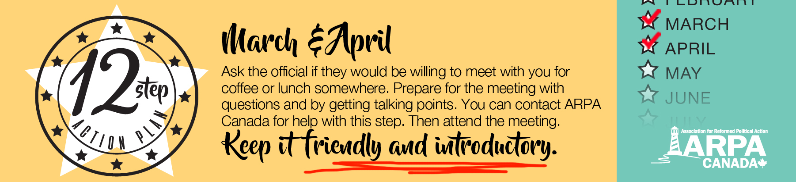
You can read all three installments on our blog at ARPACanada.ca. Do you agree or want to add nuance to the argument? Please send us any questions or comments at info@arpacanada.ca. We’d love to hear from you!
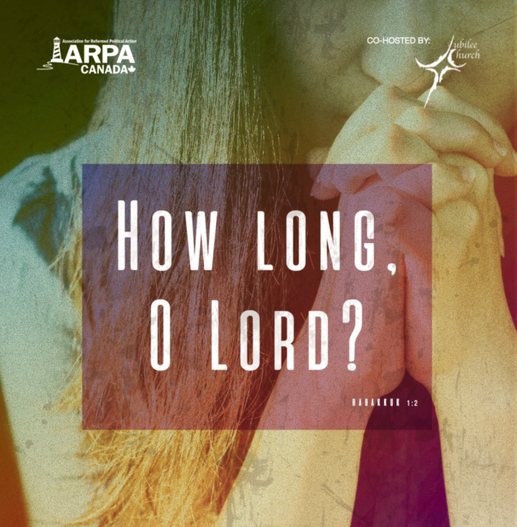
March for Life 2018
The National March for Life will be held in Ottawa on Thursday, May 10, 2018. A Reformed Prayer Service will be held in Victoria before the provincial march in BC and in Ottawa before the national march. We hope to see you there!
Ottawa Reformed Prayer Service
Where: First Baptist Church (140 Laurier Avenue West)
When: 10:30 am

Victoria Reformed Prayer Service
Where: Central Baptist Church (833 Pandora Ave.)
When: 11:30 am

Following each prayer service there will be bagged lunches for all those who pre-register. After the prayer service, head to the provincial Legislature (Victoria) or Parliament Hill (Ottawa) to join with thousands in speaking up for the most vulnerable in our society. Visit ARPACanada.ca/M4L18 for more details.
Our friends at We Need a Law are hosting their first ever mini-conference in Ottawa, from May 10-11!
Participate in the annual March for Life, enjoy the Ottawa Tulip Festival, and be energized in the fight for pre-born human rights. They have spots for only 30 people, so register today! The cost is $40 per person.

Itinerary

Thursday evening:
- Movie screening and discussion
Friday:
- Breakfast
- Presentation: All About We Need a Law
- Training Session in Pro-Life Apologetics
- Lunch
- Hit the streets of Ottawa in teams
- Debrief and depart
Contact Alicia at alicia@weneedalaw.ca if you have any questions or want to register.

“Blessed be the God and Father of our Lord Jesus Christ, who has blessed us with every spiritual blessing in the heavenly places in Christ, just as He chose us in Him before the foundation of the world, that we should be holy and without blame before Him in love, having predestined us to adoption as sons by Jesus Christ to Himself, according to the good pleasure of His will, to the praise of the glory of His grace, by which He made us accepted in the Beloved.”

~ Ephesians 1:3-6

Contact Us: 1-866-691-2772 | info@arpacanada.ca
Donations can be directed to: ARPA Canada PO Box 1377 STN B, Ottawa Ontario K1P 5R4

