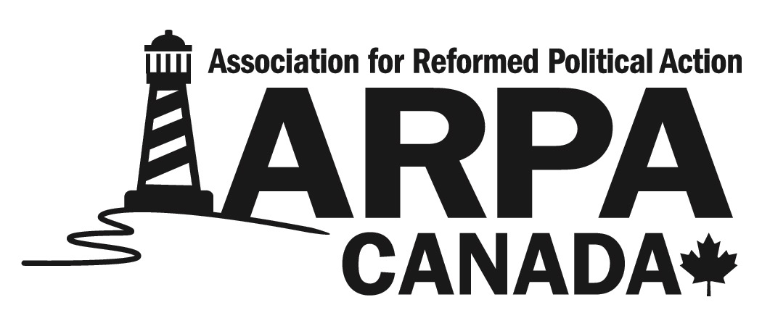
February 19, 2019

The Association for Reformed Political Action (ARPA) Canada is a non-profit organization devoted to educating, equipping, and encouraging Canada’s Reformed Christians to political action and bringing a biblical perspective to our civil governments. By God’s grace, and through the support of our donors, we are looking to greatly expand our work in British Columbia by adding a full-time member to our team dedicated to increasing the impact of our mission in that province.

Job Description: BC Manager (Full-Time)
Location: Our newly expanded Fraser Valley office, in Yarrow BC.

Start time: April or May 2019

Responsibilities:
A successful applicant will work alongside the current ARPA Canada staff and report to the Director of Advocacy and the Director of Law & Policy. The primary responsibility of the BC Manager will be to mobilize Reformed Christians in BC to effective political action and to bring a solid Christian perspective to the members of the BC legislature and other government representatives in BC. This includes:

- Grassroots Engagement:
  - Build strong relationships of mutual respect with Reformed churches, schools, ARPA groups, and individuals;
  - Communicate current political challenges and opportunities to our grassroots in BC in a way that inspires them to action (newsletters, articles, videos, presentations, face-to-face meetings, phone calls, etc.);
  - Lead by example, showing what godly political engagement can look like;
  - Assist with the formation and support of local ARPA groups and school clubs;
- Research and Writing:
  - Produce articles, policy reports, action alerts, government submissions, and a variety of other means of communication;
  - Be able to communicate policy ideas in a way that resonates with both government officials and our grassroots. This includes a variety of ages, experiences, and interests;
  - Produce newsletters, web content, and social media posts for our regular communication with ARPA’s constituents;
  - Develop expertise on the key issues that ARPA Canada focusses on and be able to interact quickly with government, media, and ARPA’s constituents on these issues.
- Public speaking/presentations:
  - Draft speech transcripts, produce PowerPoint and Prezi presentations, and be able and willing to deliver this content to a variety of audiences including schools, churches, and the public;
  - Possibility of taking part in national tours;
  - Speaking at local events/presentations, as required;
  - Assisting with ARPA Canada’s conferences (March for Life, God & Government Youth, God & Government, and youth conferences).
- Lobbying:
  - Meet regularly with public office holders with the goal of building long-term relationships and influencing public policy;
  - Propose draft legislation and policies to government officials, and assist those who are willing with research and support;
  - Prepare and present government submissions for committees, etc.;
- Media Engagement:
  - Prepare op-eds and press releases for mainstream media;
  - Take part in media interviews on particular policy issues that ARPA engages with.
- Other responsibilities may arise, depending on the skills of the candidate and requirements of the organization.
Employment Details:
- Salary, health benefits and RRSP provided;
- Salary is negotiable;
- Position start time is negotiable depending on individual circumstances.

Requirements for Applicant:
- Heartfelt agreement with the mission and core principles of ARPA Canada;
- Active membership in a confessional Reformed church (a confessional Reformed church is one that faithfully upholds Scripture and the Three Forms of Unity or the Westminster Standards) and ability to give a personal statement of faith;
- Willing to abide by all ARPA Canada staff policies;
- Proven experience with mobilizing grassroots Canadians (i.e. volunteers) to action;
- Long-term development of a Reformed Christian worldview, also at it relates to political/social issues;
- If not currently living in BC, must have previously lived there for at least three years;
- Six month trial period and minimum 5 year expected commitment;
- At least five years educational/working experience in a related field (education, communications, law, politics);
- Must be willing to travel a minimum of 20 nights a year;
- Minimum of an undergraduate degree or equivalent level of ability in regard to research/writing;
- Proficiency with MS Office and a variety of web applications;
- Self-motivated and disciplined work ethic;
- Ability to work well with a team that is scattered across Canada, through virtual means;
- Exemplify a positive attitude:
- Show love and grace to all;
- Demonstrate the fruit of the Spirit;
- Promote a positive culture of excellence and zeal for the organization’s mission;
- Respond to challenges and set-backs with godly perspective;
- Demonstrate humility and a heart of service.

Assets:
- Experience with volunteering with local ARPA groups;
- Political experience with a similar organization and/or political party.

Application Deadline: March 15, 2019 (ARPA Canada reserves the right to fill this position when a suitable candidate is found. This may mean extending the deadline);

Application Procedure:
If you are interested in the job description and meet the requirements listed above, please submit a resume, an accompanying cover letter, a personal statement of faith, the names and contact information of at least two work references and the name and contact information of one character reference (preferably a pastor or elder). Complete application packages must be submitted to Mark Penninga at mark@arpacanada.ca.

The cover letter must introduce yourself, detail how you fulfill the requirements listed above, indicate your salary requirements and address the location requirements noted above. Writing samples are welcomed (e.g. articles, papers or reports you have written).

Please Note: ARPA Canada is very grateful for any interest shown in this position. However, due to time constraints and other responsibilities, we reserve the right to not interview all applicants. The deadline for applications may also be changed as we deem necessary. Multiple interviews may be required. ARPA Canada reserves the right to not fill this position.

